Tyler Stowell

Feb 21, 2020

Question 1:

SELECT city

FROM `classicmodels`.`customers`

WHERE country = "Australia"

ORDER BY city ASC;

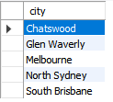

*Question 2:

SELECT employeeNumber, lastName, firstName, extension

FROM `classicmodels`.`employees`

WHERE officeCode = (select officeCode from offices where city = "Sydney");

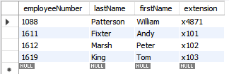

Question 3:

SELECT productCode, productName, productVendor, quantityInStock, productLine

FROM `classicmodels`.`products`

WHERE quantityInStock > 4000 and quantityInStock < 5000;

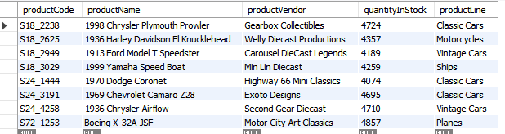

Question 4:

SELECT productCode, productName, productVendor, buyPrice

FROM `classicmodels`.`products`

WHERE msrp = (select max(msrp) from products);



Question 5:

SELECT productName, MSRP, buyPrice, (MSRP-buyPrice) AS 'margin'

FROM products

order by margin ASC

limit 1;



*Question 6:

SELECT country, count(*) as 'Customers'

FROM `classicmodels`.`customers`

group by country

having Customers > 5

order by country ASC;

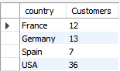

*Question 7:

SELECT pr.productCode, p.productName, COUNT(*) AS 'OrderCount'

FROM products p , orderdetails pr , orders o

where pr.orderNumber = o.orderNumber and p.productCode = pr.productCode

group by pr.productcode , p.productName

order by OrderCount DESC

limit 1;



Question 8:

SELECT CONCAT(m.firstName, ' ', m.lastName)'ManagerName' , CONCAT(e.firstName, ' ', e.lastName)'EmployeeName'

FROM employees e

INNER JOIN employees m ON m.employeeNumber = e.reportsTo

GROUP BY ManagerName;

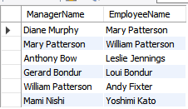

Question 9:

SELECT employeeNumber, lastName, firstName

FROM `classicmodels`.`employees`

where reportsTo is NULL



Question 10:

SELECT productName , productLine

FROM `classicmodels`.`products`

WHERE productLine = "Classic Cars" and productName > 1959 and productName < 1970

order by productName ASC

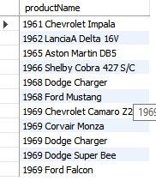

*Question 11:

SELECT monthname(orderDate) as "Month" , year(orderDate) as 'Year' , count(*) as 'Orders'

FROM `classicmodels`.`orders`

group by monthname(orderDate) , year(orderDate)

order by Orders DESC

limit 2;

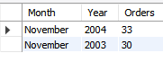

*Question 12:

SELECT distinct e.firstName, e.lastName

FROM `classicmodels`.`employees` e

left outer join customers c

on e.employeeNumber = c.salesRepEmployeeNumber

where E.jobTitle = "Sales Rep" and c.salesRepEmployeeNumber is NULL

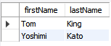

Question 13:

SELECT customerName

FROM `classicmodels`.`customers`

where country = "Switzerland" and customerNumber not in (select distinct customerNumber from orders)

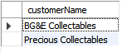

Question 14:

SELECT c.customerName , SUM(pr.quantityOrdered)

FROM customers c

left outer join orders o

on c.customerNumber = o.customerNumber

left outer join orderDetails pr

on o.orderNumber = pr.orderNumber

group by c.customerName

having SUM(pr.quantityOrdered) < 500;

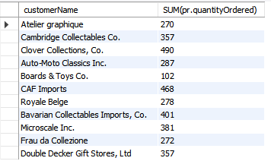

Question 15:

drop table if exists 'lowcustomer';

create table 'lowCustomers' (

'customerNumber' int(11) not null,

'contactDate' date not null,

'orderTotal' decimal(9,2) not null,

CONSTRAINT 'lowCustomer_PK'

PRIMARY KEY('customerNumber'));

Question 16:

INSERT INTO `classicmodels`.`lowcustomers`

(`CustomerNumber`,

`ContactDate`,

`OrderTotal`)

select c.customerNumber, curdate(), SUM(pr.priceEach * pr.quantityOrdered) as 'orderTotal'

from customers c

LEFT OUTER JOIN order o

ON c.customerNumber = o.customerNumber

LEFT OUTER JOIN orderDetails pr

ON o.orderNumber = pr.prderNumber

group by c.customerNumber

having OrderTotal < 50000;

*Question 17:

SELECT CustomerNumber, ContactDate, OrderTotal

FROM classicmodels.lowcustomers

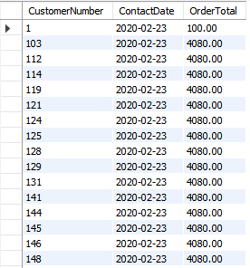

Question 18:

ALTER TABLE LowCustomers

ADD COLUMN OrderCount INT;

Question 19:

UPDATE LowCustomers

SET OrderCount = (SELECT FLOOT(RAND()*(19)))

WHERE CustomerNumber > 0;



Question 20:

SELECT CustomerNumber, ContactDate, OrderTotal

FROM classicmodels.lowcustomer

order by OrderCount DESC;

Question 21:

DROP TABLE `classicmodels`.`lowcustomers`;